Advanced Cyberinfrastructure
Research & Education Facilitators
Virtual Residency 2016

Lab 2: Exploring Opendaylight

Purpose:

The purpose of this lab is to extend your understand of SDN by using the REST API to interface with the OpenDaylight (http://www.opendaylight.org) controller.

Pre-requisites:

The user should have a basic knowledge of:
- A computer with at least 2GB of RAM and 10GB of free hard disk space
- Administrative access to your computer
- Operating System (OS) Graphical User Interface (GUI) navigation.
- Comfort with typing text into a command or shell window.
- Basic grasp of computer networking terms such as “host”, “switch”, and “IP Address”.

Lab Requirements:

- A laptop, mobile device, or access to a remote device that meets the basic hardware requirements for running Oracle’s Virtual Box.

- A functioning installation of the latest version of Oracle’s Virtual Box, available via: https://www.virtualbox.org/wiki/Downloads. Depending on your host device, you should also load the VirtualBox Extension Pack, located at the same URL.

- A copy of the “All-in-one SDN App Development Starter VM” 64bit virtual machine image, provided on a USB device, and also available within the download section here: http://sdnhub.org/tutorials/sdn-tutorial-vm/

- A functioning Internet connection.

Lab 2

In this lab section, we will install the SDN Hub All-in-One App Development Starter virtual machine on the free Oracle VirtualBox emulator. The latest version of Oracle’s Virtual Box is available via: https://www.virtualbox.org, and is supported on the majority of desktop operating systems. The SDN Hub All-in-One App Development Starter virtual machine is provided on a 16GB USB drive. Alternatively, the latest version can be downloaded here: http://sdnhub.org/tutorials/sdn-tutorial-vm/

This lab section assumes that VirtualBox is already installed on your desktop environment. The VirtualBox manual, which contains installation and operation instructions, is located here: https://www.virtualbox.org/manual/UserManual.html

Import Virtual Machine Image
Start up VirtualBox, then select File>Import Appliance and select the .ovf image that you downloaded.
You may also be able to simply double-click the .ovf file to open it up in your installed virtualization program.
Next, press the "Import" button.
This step will take a while - the unpacked image is about 3 GB.
Name your VM OpenFlowTutorial, Operating System Linux, Version Ubuntu. Click Continue.
Your VM installation is complete. Press Done.
You should now see the VirtualBox BIOS screen, followed by an Ubuntu startup menu. Allow the Ubuntu installation to fully boot (should take ~30 seconds).

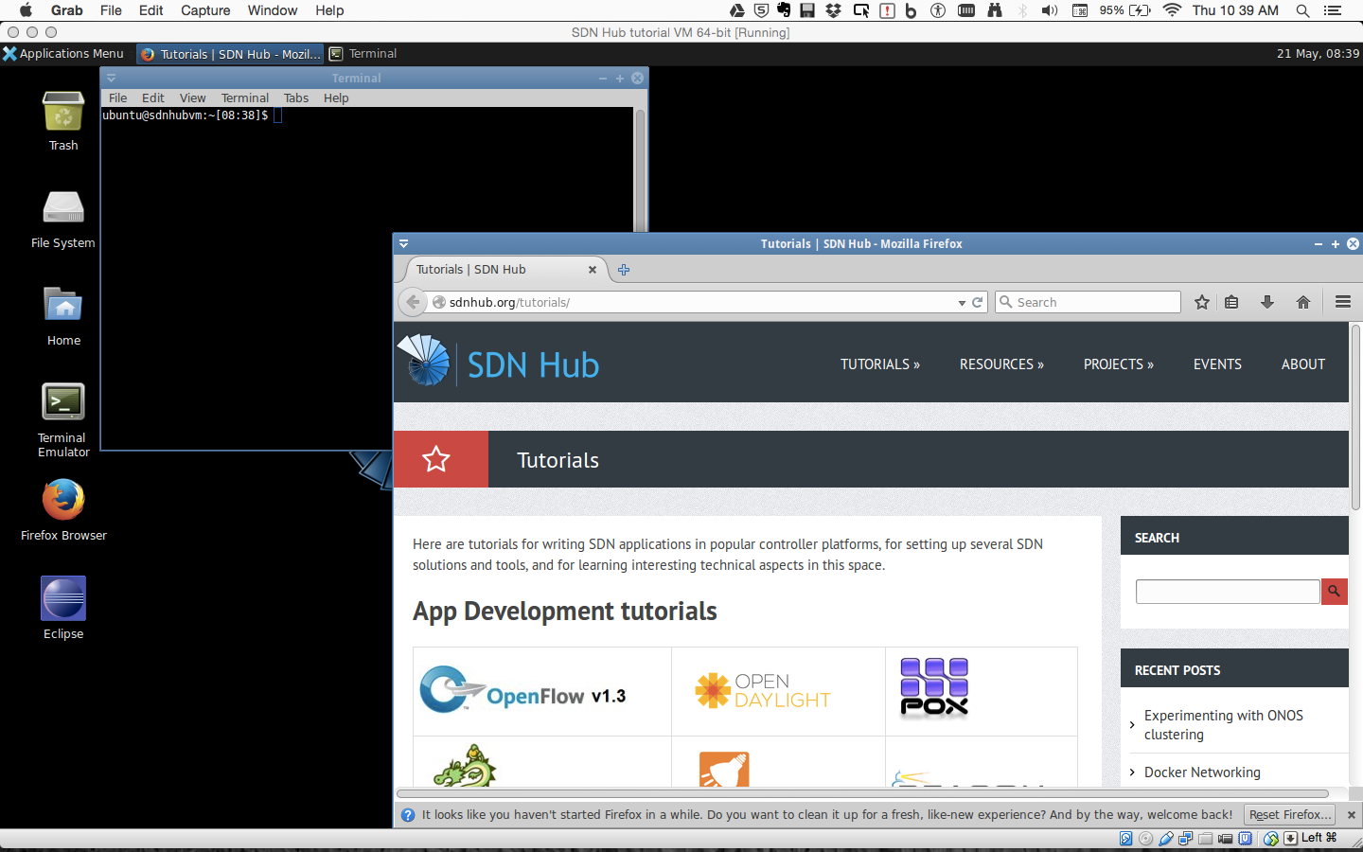

Congratulations! Your virtual machine is now ready to use.

Lab Setup

Installing Chromium (https://www.chromium.org/)
Start a Terminal Session by double-clicking on the Terminal Emulator Icon the virtual machine desktop.
Within the terminal window, type the following command:

$sudo apt-get install –y chromium-browser
Downloading Opendaylight
Within the Virtual Machine, open a web browser and go to www.opendaylight.org/downloads

Click on Pre-Built Zip File and download it

Return to the Terminal Window and, at the command prompt, type the following commands:

$cd ~
$cd Downloads
$tar –vxf distribution-karaf-0.4.2-Beryllium-SR2.tar.gz

Starting the Opendaylight Controller
Within the Terminal Window and, at the command prompt, type the following commands:

$cd ~/Downloads/distribution-karaf-0.4.2-Beryllium-SR2
$./bin/karaf

Starting the Opendaylight Controller
Within the Terminal Window and, at the command prompt, type the following commands:

$cd ~/Downloads/distribution-karaf-0.4.2-Beryllium-SR2
$./bin/karaf

Installing the needed features in the Opendaylight Controller
Once the Opendaylight controller starts, you should see a screen like this:
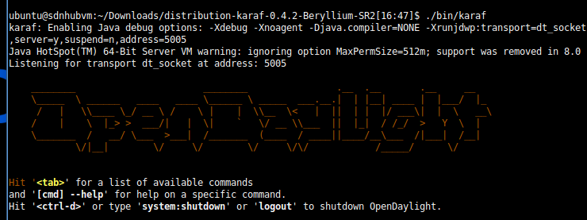
And your cursor will have changed from a $ to a >. Next, we need to install the features we’ll need for the rest of this lab. At the prompt, type in the following commands. Note: Some of these may take awhile to complete so be patient!!

>feature:install odl-dlux-all
>feature:install odl-l2switch-switch
>feature:install odl-dlux-core
>feature:install odl-dlux-node
>feature:install odl-dlux-yangui
>feature:install odl-dlux-yangvisualizer

Creating a test network using Mininet
Now that we have the controller up and running and our features installed, let’s use Mininet to create a sample network.

Start a Terminal Session by double-clicking on the Terminal Emulator Icon the virtual machine desktop.
Within the terminal window, type the following command:

$sudo mn --topo=tree,depth=2 --controller=remote

Once Mininet starts, type the following command to verify connectivity:

>pingall

Getting Started with DLUX (the Opendaylight GUI)
To log in to DLUX:
- Open a browser and enter the login URL http://127.0.0.1:8181/index.html in your browser (Chrome is recommended).
- Login to the application with username admin and password admin

Viewing Network Statistics
The Nodes module on the left pane enables you to view the network statistics and port information for the switches in the network.
To use the Nodes module:
- Select Nodes on the left pane. The right pane displays atable that lists all the nodes, node connectors and the statistics.
- Enter a node ID in the Search Nodes tab to search by node connectors.
- Click on the Node Connector number to view details such as port ID, port name, number of ports per switch, MAC Address, and so on.
- Click Flows in the Statistics column to view Flow Table Statistics for the particular node like table ID, packet match, active flows and so on.
- Click Node Connectors to view Node Connector Statistics for the particular node ID.

Viewing Network Topology
The Topology tab displays a graphical representation of network topology created.
Note: DLUX does not allow for editing or adding topology information. The topology is generated and edited in other modules, e.g., the OpenFlow plugin. OpenDaylight stores this information in the MD-SAL datastore where DLUX can read and display it.
To view network topology:
- Select Topology on the left pane. You will view the graphical representation on the right pane. In the diagram blue boxes represent the switches, the black represents the hosts available, and lines represents how the switches and hosts are connected.
- Hover your mouse on hosts, links, or switches to view source and destination ports.
- Zoom in and zoom out using mouse scroll to verify topology for larger topologies.

This concludes Lab 2

