Advanced Cyberinfrastructure
Research & Education Facilitators
Virtual Residency 2015

Lab 2: Exploring OpenDaylight

Purpose:

The purpose of this lab is to introduce the OpenDaylight (http://www.opendaylight.org) project. The user will become familiar with the OpenDaylight software defined networking controller.

Goals:

After completing this lab, users will be familiar with:
- Exploring APIs
  - Viewing information via API

Prerequisite Knowledge:

The user should have a basic knowledge of:
- Operating System (OS) Graphical User Interface (GUI) navigation.
- Comfort with typing text into a command or shell window.
- Basic grasp of computer networking terms such as “host”, “switch”, and “IP Address”.

Lab Requirements:

- A laptop, mobile device, or access to a remote device that meets the basic hardware requirements for running Oracle’s Virtual Box.
- A functioning installation of the latest version of Oracle’s Virtual Box, available via: https://www.virtualbox.org/wiki/Downloads. Depending on your host device, you should also load the VirtualBox Extension Pack, located at the same URL.
- A copy of the “All-in-one SDN App Development Starter VM” 64bit virtual machine image, provided on a USB device, and also available within the download section here: http://sdnhub.org/tutorials/sdn-tutorial-vm/

- A functioning Internet connection.

Assumptions

- Lab 1 has been completed

Lab 2

Lab Setup

In this section we will install some additional tools we will use in the virtual machine

Installng Postman, an API tool (https://www.getpostman.com/)
- Install Chromium (https://www.chromium.org/)
  - Open a terminal session. The Terminal Emulator application icon can be found on the virtual machine desktop.
  - Within the terminal window, type the following command:
sudo apt-get update
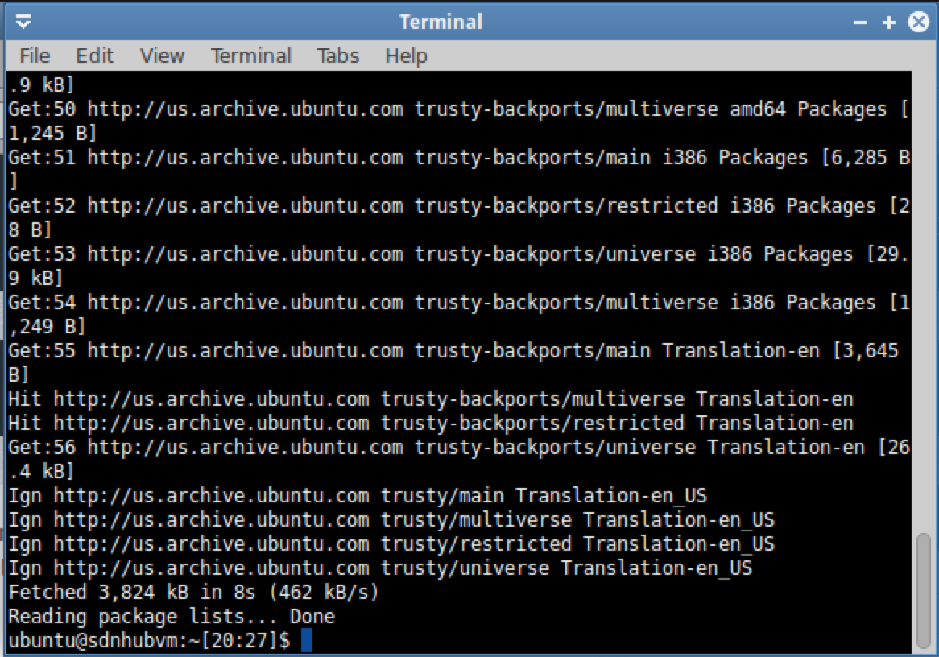
  - Within the SAME terminal window, type the following command:
sudo apt-get install -y chromium-browser
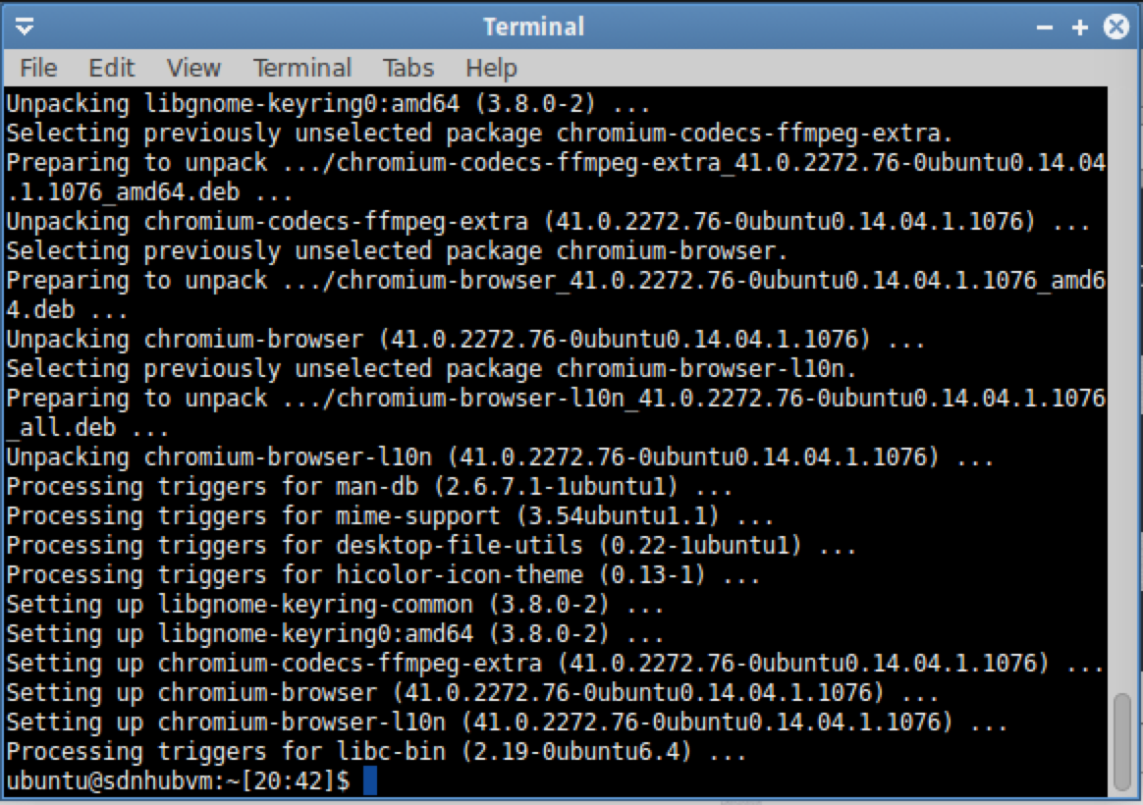
  - Start Chromium
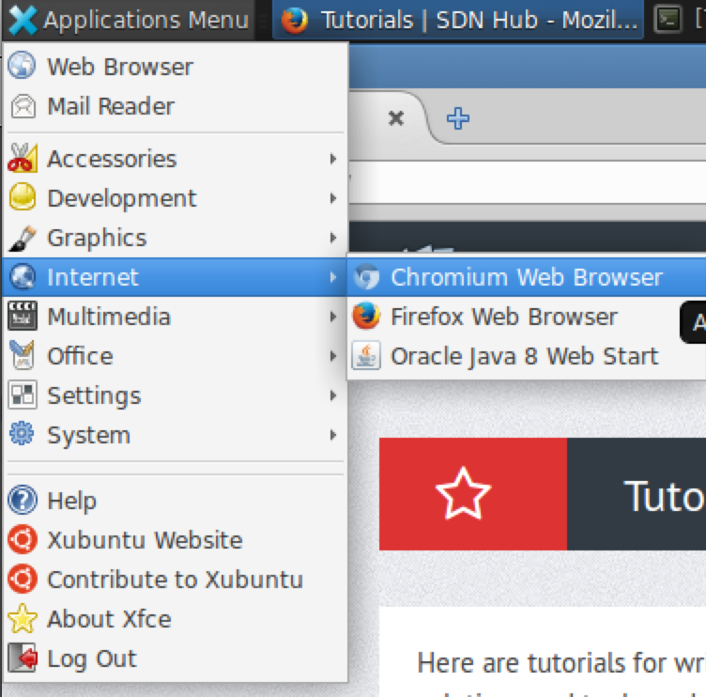
  - Go to the Postman page in the Chrome Web Store
(shortened)
http://bit.ly/1K5ZGHG
(actual)
https://chrome.google.com/webstore/detail/postman/fhbjgbiflinjbdggehcddcbncdddomop

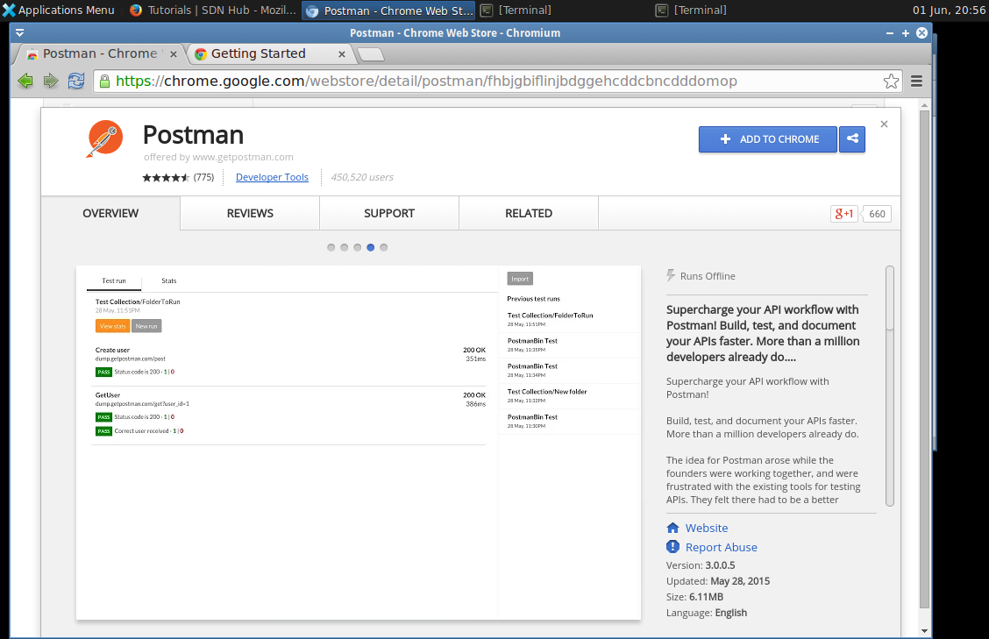
  - Select “Add to Chrome” on the upper right
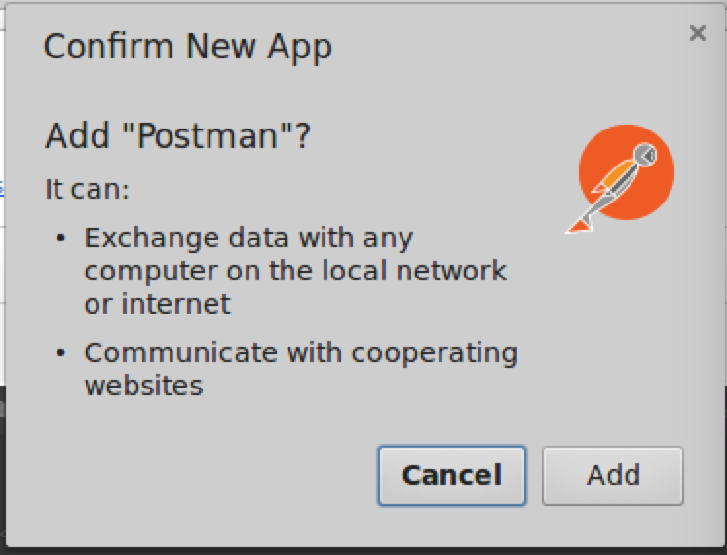
  - Select “Add” to confirm installation
  - Installation should be complete

Lab 2.1 Exploring the APIs

- Start OpenDaylight in a terminal
  - Start the “Terminal Emulator
    - Select "Applications Menu" --> "Accessories" --> "Terminal Emulator" or the “Terminal Emulator” desktop icon
  - Enter these commands
cd ~/SDNHub_Opendaylight_Tutorial/distribution/opendaylight-osgi-mdsal/target/distribution-osgi-mdsal-1.1.0-SNAPSHOT-osgipackage/opendaylight
./run.sh

- Start Mininet in a terminal
  - Start the “Terminal Emulator
    - Select "Applications Menu" --> "Accessories" --> "Terminal Emulator" or the “Terminal Emulator” desktop icon
  - Enter this command
sudo mn --topo tree,depth=2,fanout=2 --mac --switch=ovsk --controller=remote
Mininet will start with three switches and four hosts
- View the topology in the OpenDaylight web user interface
  - Open Firefox and go to http://127.0.0.1:8080
    - Username and password are ‘admin’
- View the OpenDaylight RestConf API Documentation
  - In a new Firefox windows or tab, go to http://localhost:8080/apidoc/explorer/
  - Select the “network-topology(2013-1021)” link
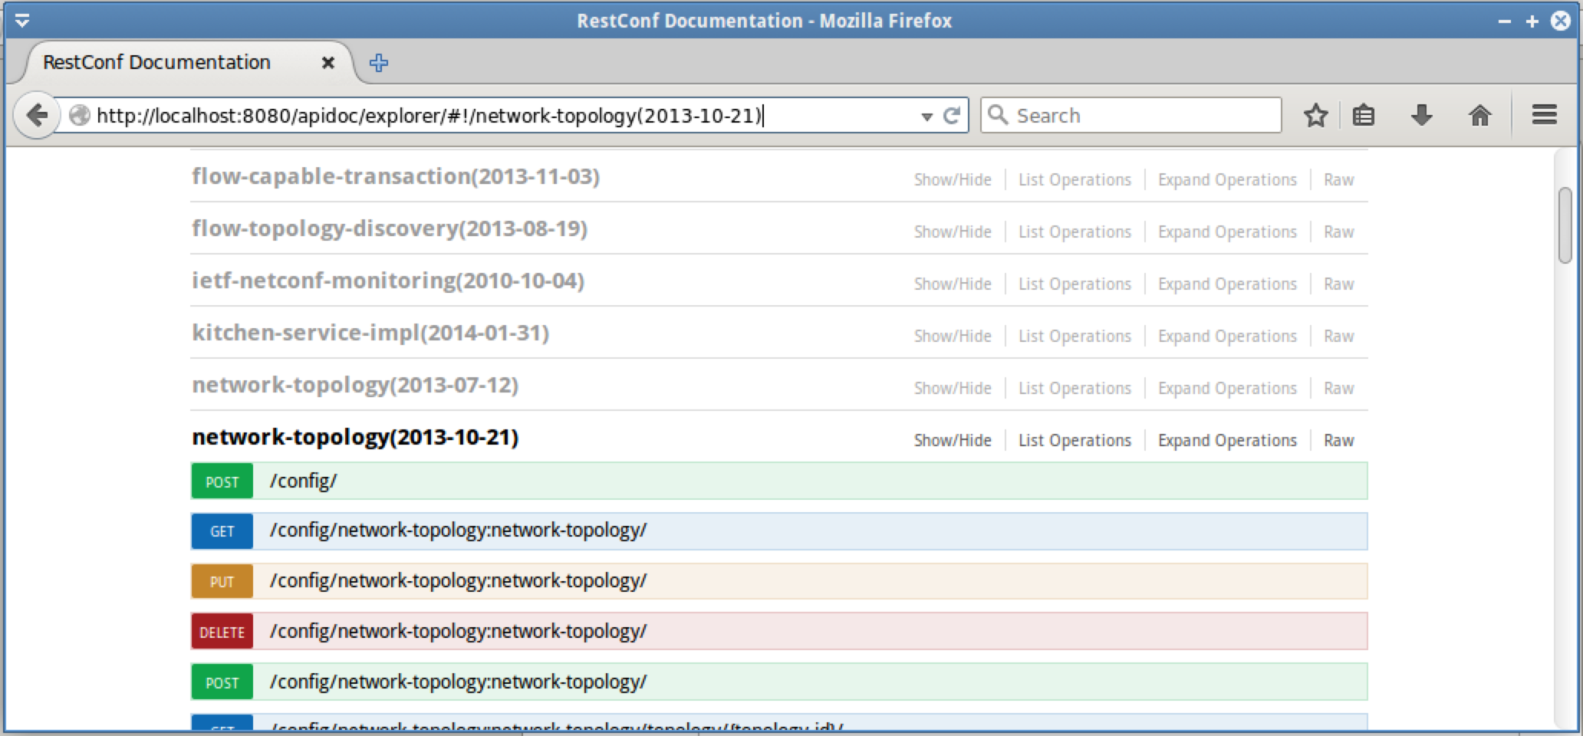
  - Scroll down and select the “GET /operational/network-topology:network-topology/ “ link
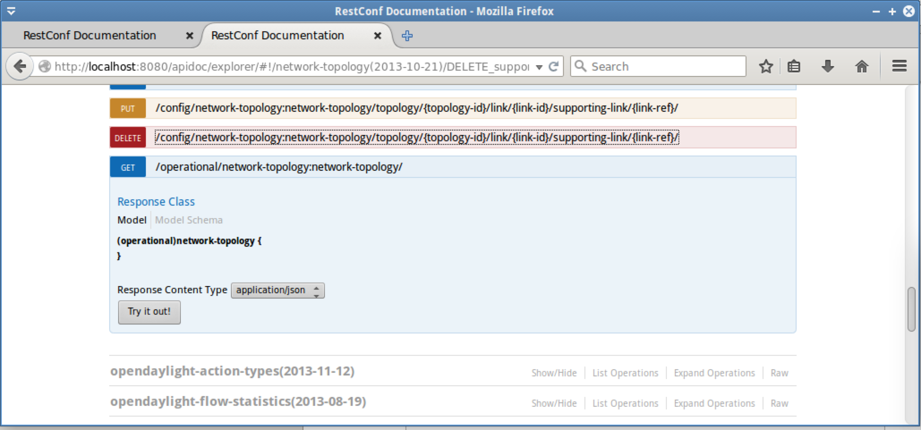
  - Select the “Try it out!” button and view the results
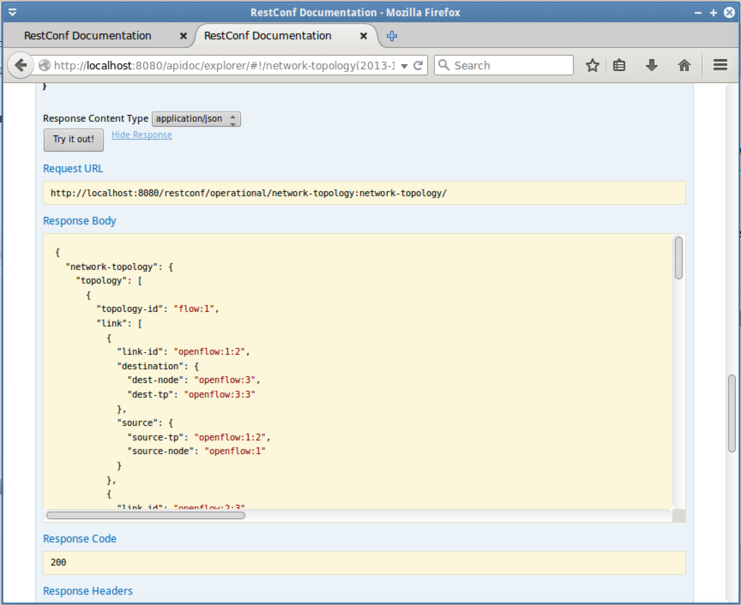
Notice the “Request URL”
http://localhost:8080/restconf/operational/network-topology:network-topology/
This is the REST API request
Notice the “Response Body”
This is the response from the Open Daylight Controller

  - Generate some traffic in Mininet

    - Switch to the Terminal running Mininet
    - At the “mininet>” prompt, enter this command
pingall

This will cause all four hosts to ping each other

  - Switch to the Firefox browser running the OpenDaylight web user interface and reload the page
Notice that the hosts have been discovered now
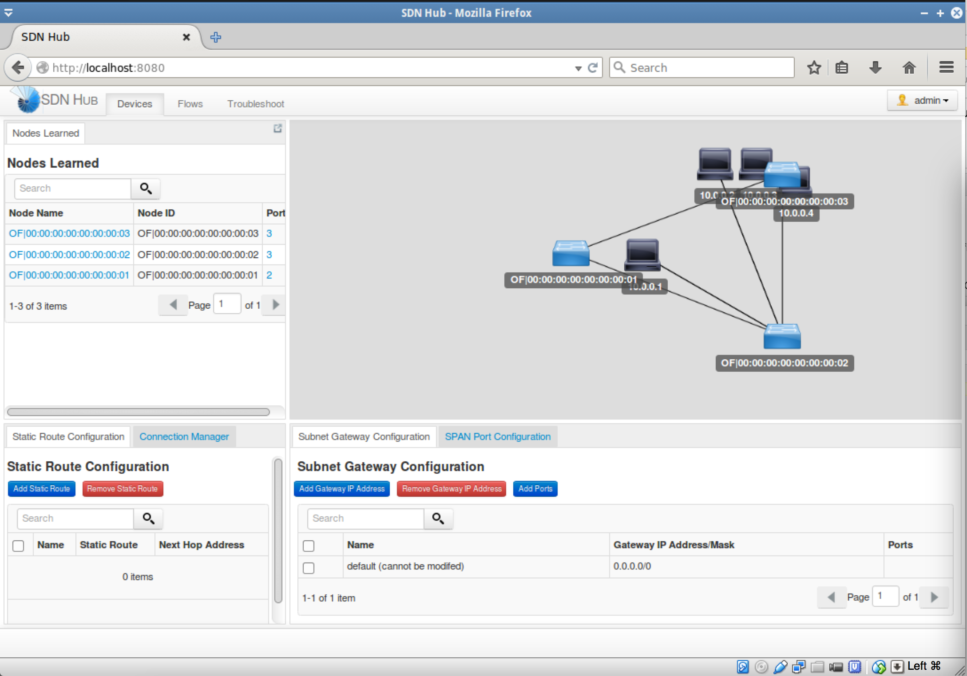
  - Start “Postman”
    - Select "Applications Menu" --> "Chromium Apps" --> "Postman"
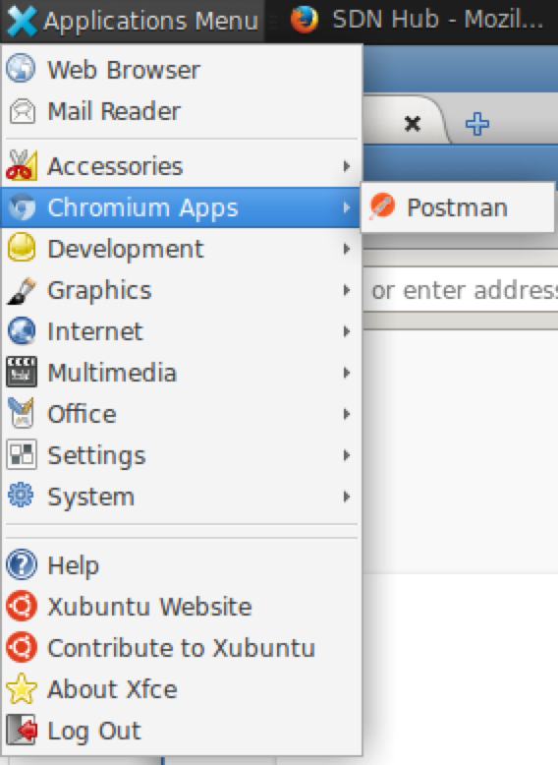
At startup select “Go to the app”
  - Lets try a different API, View “GET /operational/opendaylight-inventory:nodes/“ in Postman
    - In the “Enter request URL here” field enter http://localhost:8080/restconf/operational/opendaylight-inventory:nodes/
You now see information regarding the devices on the network, including the controller
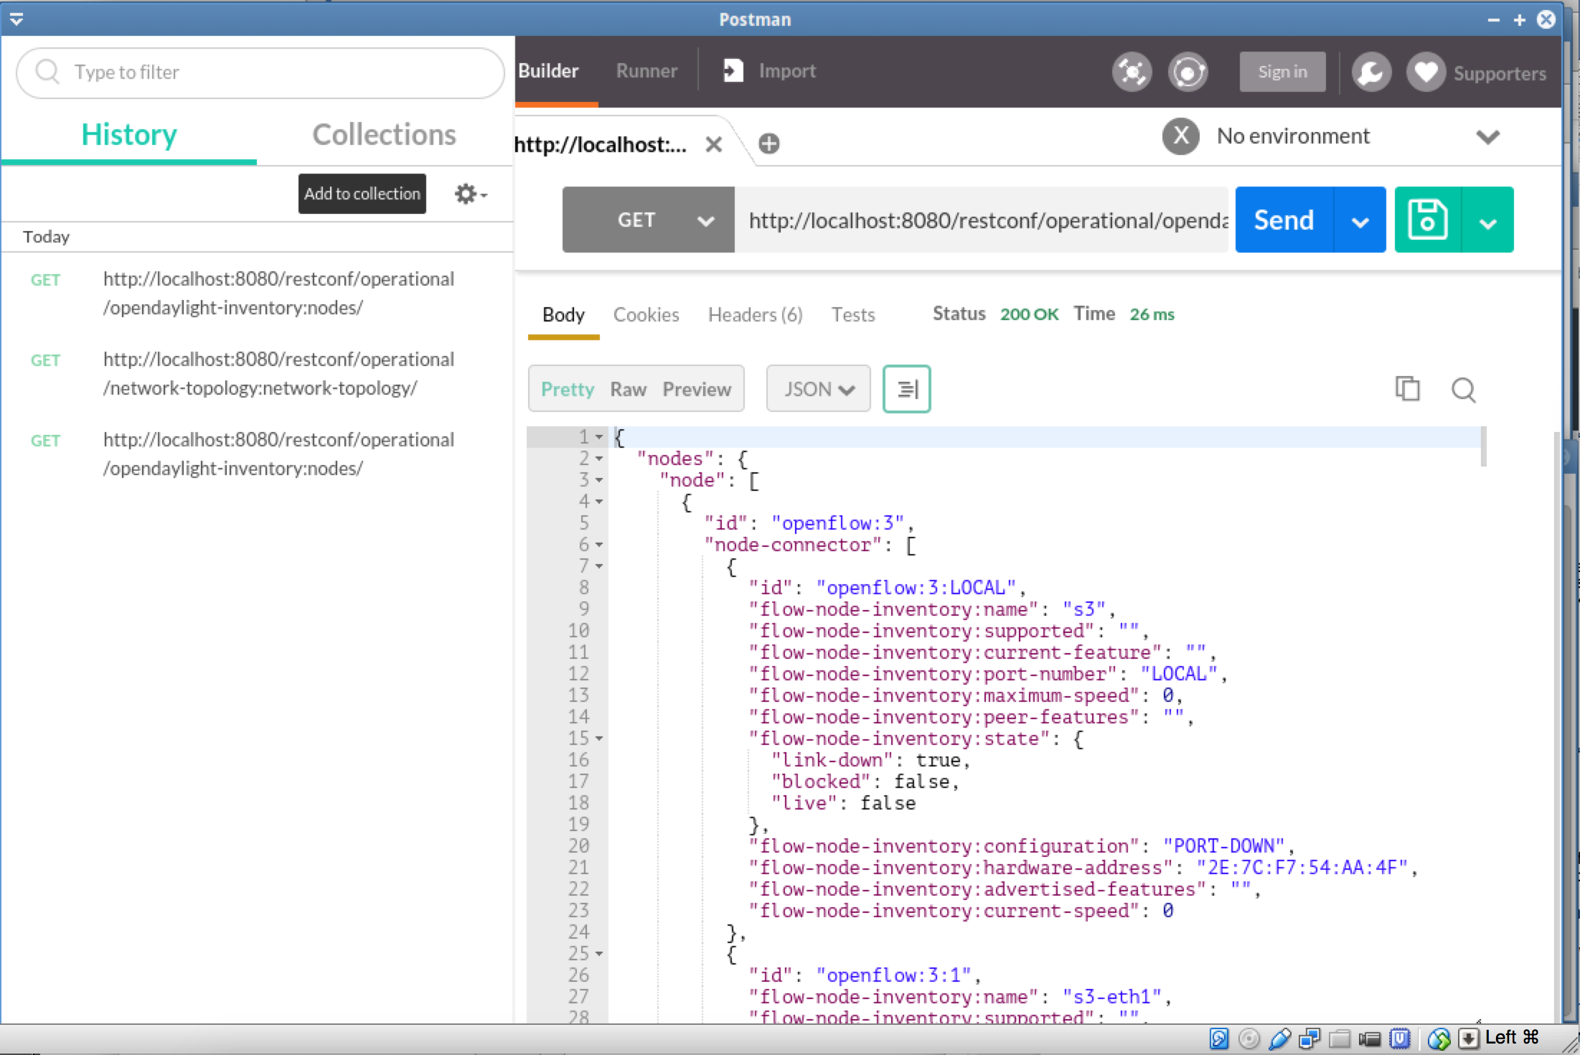

Congratulations!
You have used a REST API to interact with an Open Daylight Controller

